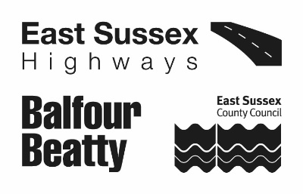 | APPLICATION FOR CONSENT TO MAKE AN EXCAVATION IN A STREET  HIGHWAYS ACT 1980 SECTION 171 | S171  APPLICATION

APPLICATION  REFERENCE |  | OFFICE USE ONLY | EXPIRY  DATE |  | OFFICE USE ONLY
WORKS LOCATION
(including Postcode and geo-location)
Application Date
Estimated Start Date
Expected Duration
Works Description
Name of Applicant
Address of Applicant
Telephone Number
Email Address
Estimated Works Cost |  | £
I wish to apply for a licence to carry out works on the highway at the above location as described above. As requested, I enclose the following in support of my application.
- Proof of our Public Liability Insurance to the value of £10 million, valid for the proposed duration of the works.
- Proof of NRSWA Accreditations for the works supervisor and operatives.
- Payment payable to East Sussex Highways in accordance with the fee structure found East Sussex Highways website. All statutory undertakers drawing will be supplied in the costings. The fee must be paid prior to the licence application being processed, and you will be contacted by us to collect this fee.
- Please attach planning permission if required & all relevant drawings.
- Estimated cost of the works are to include all traffic management requirements which is involved in the construction of the works i.e. (Traffic Lights)
- Road space & permits may be required before any construction works start, this will be instructed in the issuing of the S171 licence & conditions.
I understand that if my application is successful, a licence will be issued by the Highway Authority granting consent to undertake the works described, in accordance with the standard and site specific conditions stated therein.
Name (please print)
Signed |  |  |  | Date

Please submit your application by email to:

