East Sussex Highways

Road Traffic Regulations Act 1984

Temporary Traffic Regulation Order

Application Pack

ROAD TRAFFIC REGULATION ACT 1984

SECTIONS 14, 15 & 16A

Temporary Traffic Regulation Order - Guidance Notes for Applicants

Background:
Temporary Traffic Regulation Orders (TTROs) can be provided when a works promoter, hereinafter referred to as the “applicant” has no option, other than to close a road or alter existing traffic arrangements as shown below, to carry out their proposed works. A further section of the Road Traffic Regulation Act 1984, Section 16A, is applicable to sporting events or other special events on the highway. There are time scales that must be followed legally, key stakeholders must be consulted and particular information must be made public. This is also set out in more detail below. The same, or very similar, procedures also need to be followed if the applicant decides, at any time, that changes are required, e.g. a change of dates to the original TTRO.

Timescales for Applications:
Applicants must give at least three months notice to enable an Order to be processed. It is stressed that failure to provide full and correct information may cause a delay in the processing of the TTRO. Under these circumstances it may not be possible to achieve the dates requested.

Provision of Orders:
Temporary Traffic Regulation Orders include temporary road closures, temporary speed limits, temporary no waiting at any time orders, parking restrictions, one way orders being revoked/direction of travel changed, closures of different sections of road at different phases of the job, HGV’s diversion routes. NOTE: Public footpath and bridleway closures are usually processed by East Sussex County Council Rights of Way team.

Sections 1 to 6 - Information Required:
Each section should be completed in full. The following details, shown in bold type, must be provided -

- Road Name For example – Tunbridge Wells Road
- Road Number if “A” or “B” Class road. For example – A267.

- Town or Village For example - Frant
- Grid Reference This should be 12 figure easting and northing.
- Type of Order Required. For example – road closure, temporary speed restriction etc

- Extent of highway affected Description containing details of end points of closure, speed restriction etc

- Proposed diversion route if applicable The Network Management Team may request an alternative diversion route if deemed necessary. Please contact the office to discuss a diversion route if you are unsure on a suitable alternative route.

Section 7 – Permanent Traffic Orders to be changed
If there is a permanent traffic order that needs to be temporarily suspended for the works to be carried out, the applicant should provide details, i.e. suspend existing 40mph speed limit to implement a temporary 30mph speed limit.

Section 8 - Consultation
Prior to making an application for a TTRO the applicant must discuss their proposals with East Sussex County Council Public Transport Services, contact details can be found in section 8 of the application form. This is to ensure that the Public Transport Services team is aware of the proposal and to enable them to take or require the applicant to take such action as Public Transport Services consider necessary. It is important that details of the consultation with Public Transport Services are provided with the application. It is insufficient to solely indicate that Public Transport Services has been consulted.

The Network Management Team may advise of further consultations if it is deemed necessary.

Sections 9 to 12 – Contact details for the contractor carrying out the works
Applicants should provide correct contact details for the contractors carrying out the proposed works. A 24hr contact telephone number must be provided.

Section 13 – Insurance
Applicants other than utilities must provide proof that they hold £10 million Public Liability insurance to work on the highway.

Sections 14 to 17 - Payments
Applicants must provide a payment order or payment reference number plus the address to which the invoice for the TTRO can be sent, with their application. Our current fee structure is available to view below:
https://www.eastsussexhighways.com/application-forms

Section 18 – General enquiries contact number
A telephone number must be provided for enquiries regarding the scheme. This must be suitable for distribution to the general public if necessary.

Section 19 – Street Manager permit no. / Works reference no.
A works reference number should be submitted with all applications. Where the applicant or their contractor has the facility to raise electronic permits the Street Manager permit reference should be provided.

Maps
Applicants must provide at least two maps/plans to a minimum scale of 1:2500. The maps/plans must show the exact position of the road closure or one-way restriction etc. At least one map/plan should show the outline of the diversion route and at least one map/plan should show the proposed signing on the diversion route.

Completed applications should be returned to: Network Management Team
East Sussex Highways Ringmer Depot
The Broyle Ringmer East Sussex BN8 5NP

Email: networkmanagement@eastsussexhighways.com

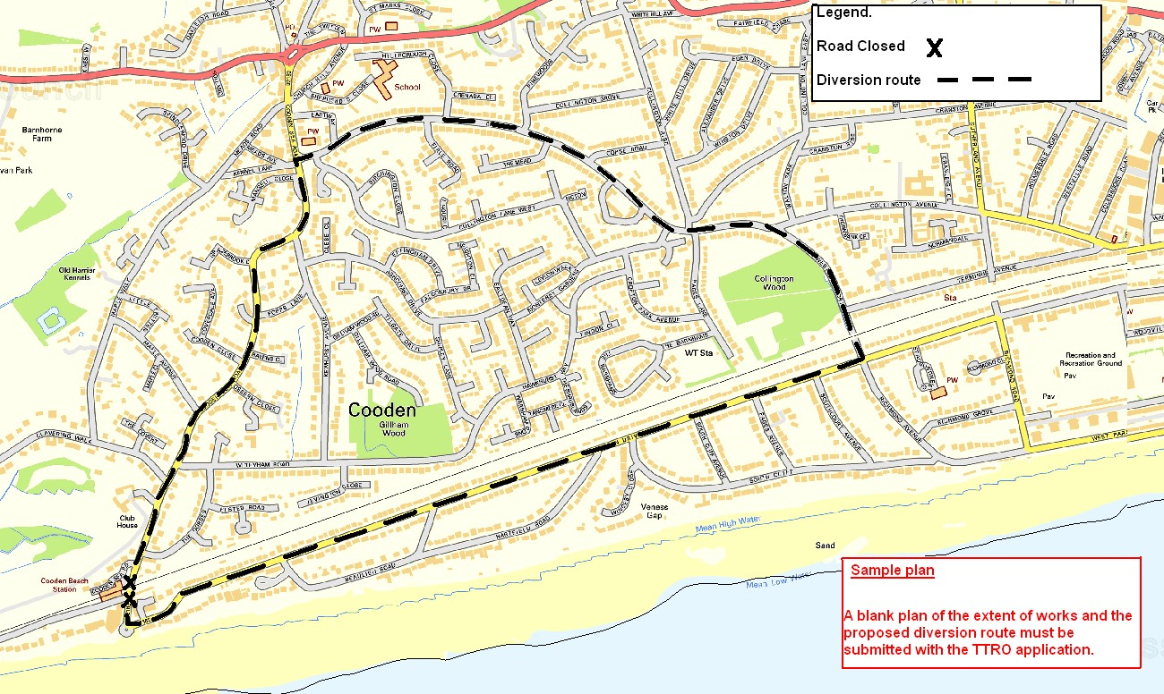

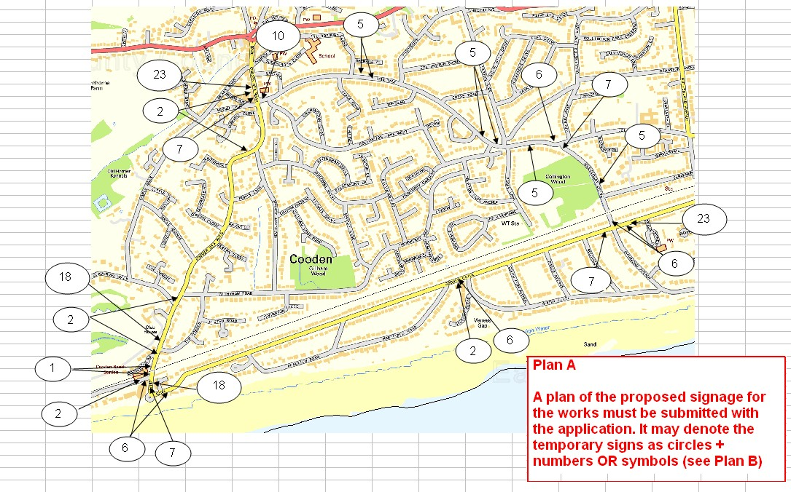

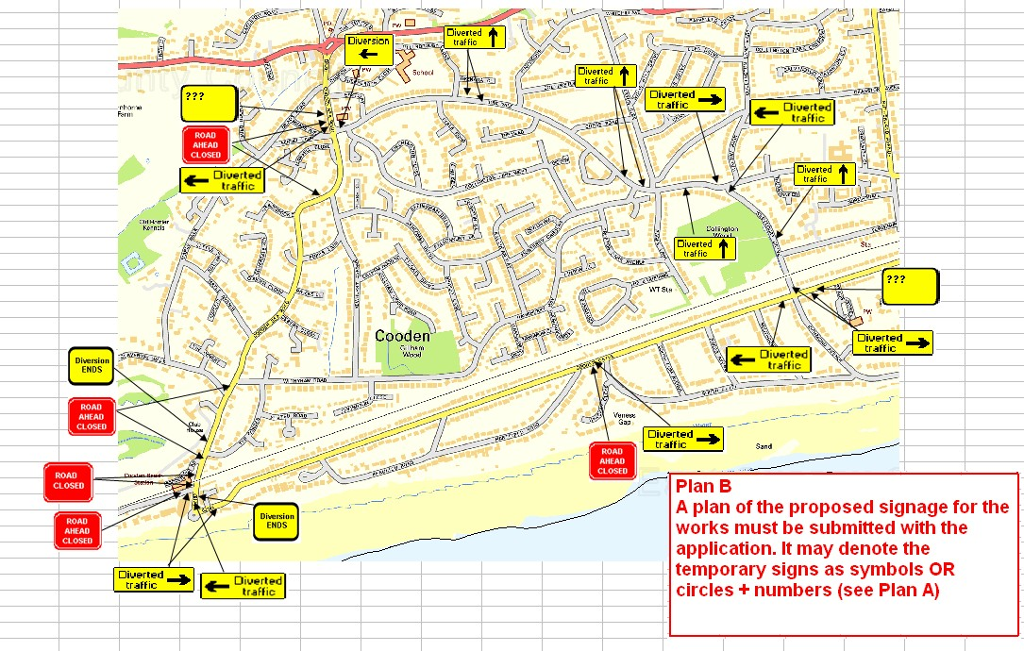

Signing Schedule For Road Closure

Road No Road Name Town
MG Sign  No | Sign | Number  Required | Detail | TSRGD
1 |  |  |  | 7010.1
2 |  |  |  | 7010.1
3 |  |  |  | 7010.1
4 |  |  |  | 7010.1
5 |  |  |  | 2703
6 |  |  |  | 2703
7 |  |  |  | 2703
8 |  |  |  | 2702
9 |  |  |  | 2702
10 |  |  |  | 2702
11 |  |  |  | 2706

MG  Sign No | Sign | Number Req’d | Detail | TSRGD
12 |  |  |  | 2706
13 |  |  |  | 2706
14 |  |  |  | 2702
15 |  |  |  | 7002B
16 |  |  |  | 2703
17 |  |  |  | 2703
18 |  |  |  | 2703
19 |  |  |  | 2702
20 |  |  |  | 2702
21 |  |  |  | 2702
22 |  |  |  | 2702

[Section 1]  LOCATION: |  | Road No
 |  | Road Name
 |  | Town/Parish
[Section 2] TYPE OF TEMPORARY ORDER REQUIRED  If completing form by hand please circle/ highlight required temporary order |  | Road Closure |  | YES / NO |  | Applicants must provide at least two maps/plans to a minimum scale of 1:2500. The maps/plans must show the exact position of the road closure or one-way restriction etc – see Guidance  Notes for  Applicants.
 |  | Speed Restriction  Speed Limit |  | YES / NO
 |  | One Way Order (Provide details in Section 4) |  | YES / NO
 |  | Prohibition of Waiting At Any Time |  | YES / NO
 |  | Time (no parking) |  | YES / NO
 |  | Suspension of Parking |  | YES / NO
 |  | Restrictions |  | YES / NO
 |  | Footway Closure |  | YES / NO
 |  | Public Right of Way (Footpath/Bridleway) |  | YES / NO
 |  | Weight Restriction |  | YES / NO
 |  | Other
[Section 3] EXTENT OF HIGHWAY
AFFECTED:
 |  | TQ Ref: |  | Length of works (metres) =
[Section 4] REASON FOR TEMPORARY ORDER:
[Section 5]  DATE FROM: |  |  |  | DATE TO:
DURATION OF WORKS:
[Section 6]
PROPOSED
DIVERSION
ROUTE IF
APPLICABLE: | Diversion route & signing schedule must be attached. This may alter depending on the location,
 | traffic flows, or other works/events
[Section 7] PERMANENT TRAFFIC ORDERS TO BE CHANGED IF NECESSARY:
[Section 8]
For all temporary orders, applicants must send this application to East Sussex Highways, Network Management team or attach to Streetmanager PAA/Permit application:
Email: - networkmanagement@eastsussexhighways.com

Processing of applications may be DELAYED if supporting statements are omitted.
Signature (Applicant)

Print (Applicant)

Date: (Applicant)
[Section 9] CONTRACTOR CONTACT:
MANDATORY
[Section 10] CONTRACTOR ADDRESS
MANDATORY
[Section 11] CONTRACTOR TEL NO. AND EMAIL ADDRESS: MANDATORY  Daytime Tel No:  Email Address: |  |  |  | [Section 12] OUT OF HOURS CONTACT AND TELEPHONE NO.  MANDATORY  Out of Hours Tel No:
[Section 13] Insurance: Public liability insurance to a minimum of £10 million must be provided. (Proof to be submitted with this form)
Company Name:

Address:

Tel No:

Policy No:

Expiry Date:

[Section 14]
Company Name who will be paying the invoice
Mandatory
[Section 15]
Address to send invoice to
Mandatory
[Section 16]
Contact name who has requested road closure
Mandatory
[Section 17]
Purchase Order No. / Order Reference No. (if applicable)
Mandatory
[Section 18]
General enquiries telephone number (to be provided to members of public if necessary) Mandatory
[Section 19]
Street Manager permit no. / Works reference no. (if applicable)
Internal Applications only:
ESH Project Manager’s Name: | Tel No:
ESH Snr Tech Name: | Tel No:
Please insert SAP COST CODE / GL CODE below

Cost Code / GL Code

